ASSIGNMENT ON DISK PARTITIONING, SECTORS AND CLUSTER

INTRODUCTION

We have covered through the term how virtualization works from the CPU, how memory management is utilized and implemented with traditional and modern operating systems as well as some algorithms that can be implemented to tackle some of the common problems that arisen when designing an efficient OS. This week we covered how OS implement swapping algorithms to move efficiently pages from memory to disk and to retrieve them when a process needs to access such information as well as how to build algorithms that can provide effectiveness even if the hardware resources are limited.

ACTIVITY

This activity aims to understand how a disk is partitioned using the NTFS system, we are using the NTFS utility to provide a summary of such partitions on sectors and cluster as well as relevant information about the partition.

Attach YOUR screenshot from running NTFSinfo utility

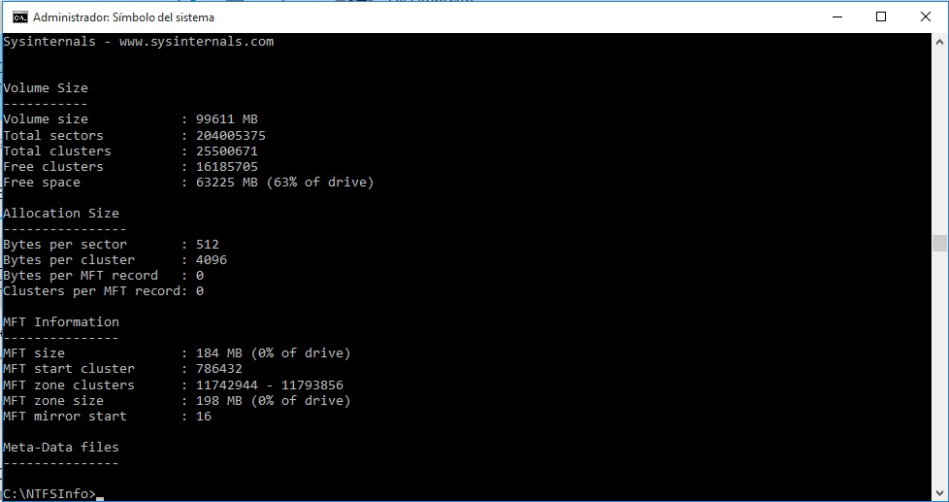
List the number of sectors and define what it means
When running the utility it displayed 204005375 which is the sum of all the smallest physical storage unit, which according to my system is 512 bytes (NTFS: Hard Disk Drive Basics, 2019).

List the number of total clusters and define what it means

A cluster is a group of one or more consecutive sectors which is more frequently 2^3 sectors and based on the results obtained from running the applet I have clusters of 8 sectors, I just divided the total of sector on the total of clusters and the result was 8.000 rounded to three decimal places (NTFS: Hard Disk Drive Basics, 2019).

List the number of bytes per cluster and define what it means
As we can see the numbers are relative to the smallest units, in my case since I have cluster of 8 sectors and sectors of 512 bytes we can easily figure this number out by multiplying the number of sectors by the number of bytes per sectors giving us a total of 4096, the same result obtained from the screenshot taken from the running applet.

Translate the number of free clusters from a decimal number to a hexadecimal
Decimal value: 16185705
Hexadecimal value: F6F969

CONCLUSIONS

This assignment was relatively easy to do, the only thing I found time-consuming was learning to use the windows terminal with all permissions, initially, I tried following instructions and the system would give me an error where I had no permissions to execute the applet on the disk. After some browsing on the internet, I found that opening a shell as an administrator user would fix the issue. The utility is pretty simple and intuitive to use and summarizes how the disk is partitioned.
A got to learn a bit more how the disk is divided and how the storage is allocated in sectors and cluster.

Reference list.

- Arpaci-Dusseau, R. & Arpaci-Dusseau, A. (2012). Operating Systems: Three Easy Pieces. Madison, WI: University of Wisconsin-Madison. Available at http://pages.cs.wisc.edu/~remzi/OSTEP/

- NTFS: Hard Disk Drive Basics. (n.d.). Retrieved from http://www.ntfs.com/hard-disk-basics.htm

